
Tashiling Shingmin Dulen & Tshongdrel Tshogpa
Cross Cutting Management Regime: Non-Wood Forest Produce

plan period: 2022-2026
DivisioNal forest office, sarpang
GEWOG: JIGMECHOLING

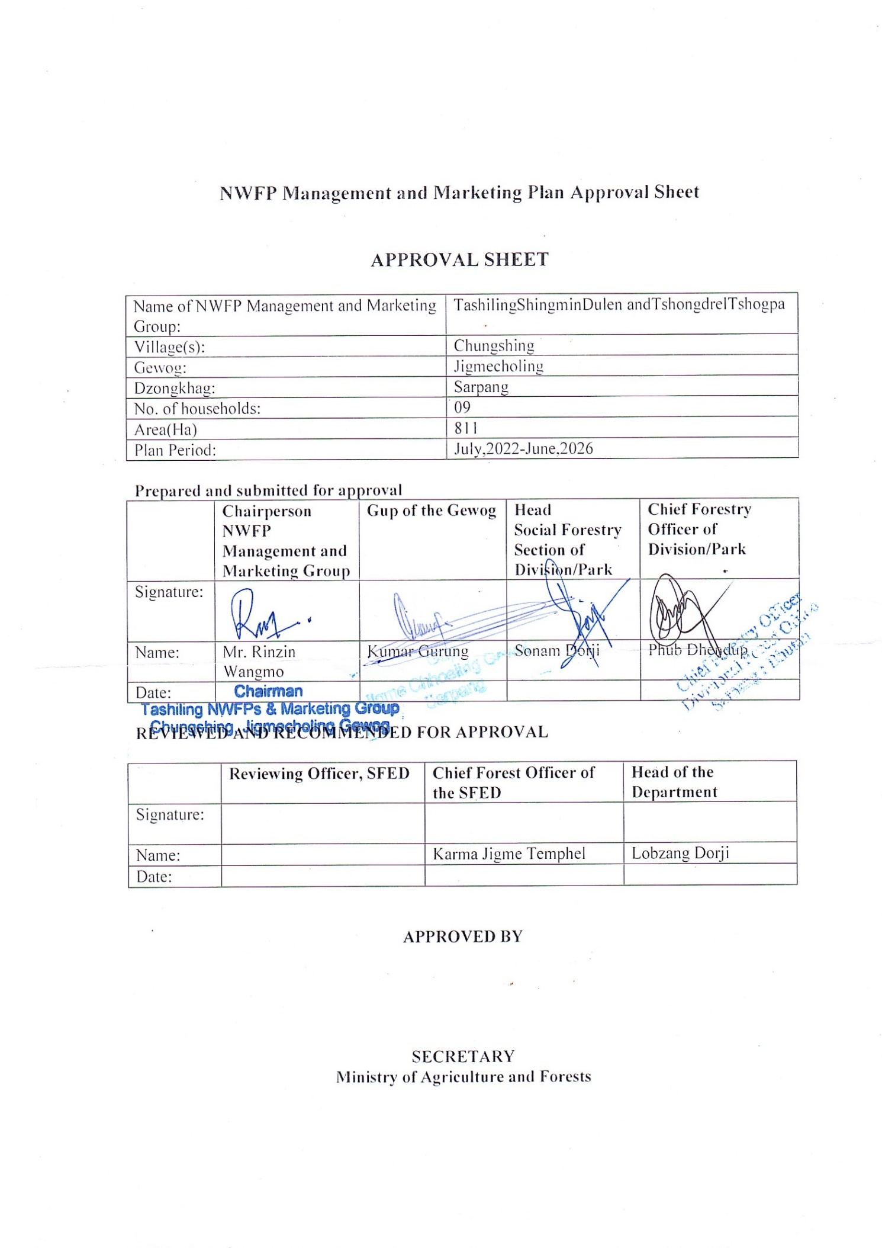

Table of Contents
1. Background 1
2. Goal 2
3. General objectives 2
5. Description of NWFP 2
6. Harvesting prescriptions for sustainable harvesting 4
7. Google/QGIS map of the NWFP harvesting 7
8. Marketing and sales plan 8
Table 04: Marketing and sales plan 8
9. Marketing arrangements 9
10. Benefits to the members 9
11. Benefits to the group 12
12. NWFP management & marketing group members 13
12.1 Responsibilities and rights of members 13
13. Executive committee 14
13.1 Responsibilities of Chairperson: 14
13.2 Responsibilities of Secretary: 14
13.3 Responsibilities of Treasurer: 15
14. Tenure of committee member 16
15. Incentives to the committee members 16
16. New Membership 16
16.1. Resignation of members 16
17. NWFP group fund management and utilization 17
18. Conflict Management 17
Conflict resolution 17
19. Groups meeting and purpose 18
20. Fines and penalties 18
21. Tenure of the management plan 19
22. Power of the Department 19
23. Monitoring and evaluation scheme 19
Annexure I: Name lists of the Tashiling Shingmen Duelen and Tshongdrel Tshogpa, Chungshing. 21

Part A: Tashiling Non-wood Forest Product Management and Marketing Plan

1. Background

Chungshing village is located in the south-east of Jigmecholing gewog and is 10 km away from the Gewog Administration Office. The village was formed with extension of family members in the gewog and today there are 9 households. They fully dependent on agriculture farming and forest resources since the time of immemorial for their livelihood.

The collection area of Tashiling NWFP management and marketing group is approximately 811 hacters within the altitudinal ranges of 1500-1600 masl. Out of this 376.73 ha falls in Biological Corridor (BC-3) and 3.88 ha inside Jigme Singye Wangchuck National Park.
The canopy cover of Tashiling NWFPs area overlapping with with different forest types are; open forest is 24.64 ha, moderately dense forest (40-59%) is 25.21 ha , and dense forest (60-69%) is 39.82 ha. Under the dense forest (70-100%) overlapped area of 670.77 ha 72.61 hacters is inacessable with slope greater than 45 degree. Further, within it 57.16 ha is Private Registered land of the villagers. The boundary geocoordinates of the collection area is given in table 01.

Table 01: The boundary geo-coordinates of Tashiling NWFP collection area.
Sl no | Boundary name | Latitude | Longitude | Direction
1 | Jigme Singye Wangchuck Ntional Park | 27° 2'40.86"N | 90°33'48.78" | East
2 | Ranzapong | 27° 1'50.30"N | 90°34'4.34"E | South east
3 | Rongri zampa | 27° 1'8.39"N | 90°33'34.41"E | South
4 | Kuibrang | 27° 2'7.83"N | 90°32'33.63"E | West
5 | Shamapong | 27° 3'22.43"N | 90°32'30.08"E | North

NWFP species grows in pocket/sporadic area. I t is mostly dominated by Tsoe (Rubia cordifolia), Amala (Phyllanthus emblica), Pipla (Piper longum), Kauwla (Persea gamblei), Chipley (Pouzolzia spp), Harchur (Viscum articulatum) and Kucho (Thysanolaena latifolia).Bamboo shoot (Dendrocalamus hamiltonii) and Guli (Persea frutifera),

To ensure the sustainable management of above resources and to add conservation value to above resources, formation of NWFP marketing group is essential to hand over resources management right to community. The transfer of right is expected to enhance building of social institute for forest resources management and balance socio-economic development within the village and ensure sustainable management of NWFP resources through legalised harvesting.

2. Goal

Enhance social livelihood of the group through sustainable harvesting and marketing of NWFPs

3. General objectives

- Sustainable management and utilization of NWFP resources.
4. Specific objectives

The specific objectives are as given below:

- To promote group collection and marketing of NWFP from the proximity of settlements
- To earn income from sale of NWFPs and reduce poverty

- To ensure sustainable management of NWFP through introduction of regulated collection system.

5. Description of NWFP

Depending upon the types of forest stated in the back ground, different species of NWFPs are found in the area. However, in case of Chungshing village the main NWFPs found are; Sanja (Strobillanthus flaccidifolius), Tsoe (Rubia cordifolia), Amala (Phyllanthus emblica), Pipla (Piper mullesua), Guli (Persia fruitifera fruits), Shikarilara, Chipley (Pouzolzia spp), Kucho (Thysanolaena latifolia), Rushing (Ficus spp.)Labsi (Choerospondia axillaris), Kauwla (Persea gamblei), Harchur(Viscum ariculatum) LambuPipla (Piper longum), Pangra (Entada rheedii), Dendrcalamus himaltonii(choyabans), Recha (Plectocomis himalayana)and Jang leypan(Piper lingum).The Chungshing community have had collected it for domestic use and also for commercially purposes based on demand. The group have enlisted to collect 13 species of plant based NWFPs for commercial purpose as the location of the village on the periphery of the state reserved forest favours its collection. Table below shows on the detail description of NWFP species available for harvest by the group.

Table 2: Brief description of NWFPs for commercial harvesting

NWFP name | Harvesting area | Parts harvested | Use purpose (traditional & others) | Harvesting season | Estimated quantity that can be collected in a year
Sanja  (Strobillanthus flaccidifolius) | Ranzapong  Shamkon | Leaves | Dye | Dec-Jan | 25 Kg
Tsoe  (Rubia cordifolia) | Ranzapong  Shamkon | Entire plant | Dye, medicinal | Nov-Feb | 150 kg
 |  |  |  |  | 50 kg
Amala  (Phyllanthus emblica) | Samapong | Fruits | Medicinal, Incense | Nov-Feb | 100 Kg
Pipla  (Piper mullesua) | Romgang | Fruits | Medicinal | Jan-Feb | 50 Kg
Guli  (Persea frutifera) | Tshochen,  Ranzapong | Fruits | Medicinal | Jan-Feb | 100 Kg
Chipley  Pouzolzia spp) | Romgang | Bark | Incense, Medicinal | August-Feb | 120 Kg
Broom  (Thysolaena latifolia) | Shamkon | Upperpart | broom | Dec-March | 60Pcs
Labsi  (Choerospondia axillaris) | Shamkon | Fruit | Pickle | Dec-February | 60kg
Kawlo  (Persea gamblei) | Romgang | Bark | Medicine  Incense | Oct-February | 120 kgs
Harchur  (Viscum articulatum) | Ranzapong | Whole plant | Medicine | Any time | 20 kgs
Pangra  (Entada rheedii) | Tshochen,  Samkon,  Ranzapong | Bean | Medicine | Nov-December | 100 kgs
Choya bans  (Dendrocalamus hamitonii) | Yongsan,  Kuibang,  Shamapong | Bamboo shoot | Consumption | July-August | 50 kgs
Recha  (Plectocomia himalayana) | Tshochen | Shoot/entire stem | Consumption | Dec-March | 100 Nos

6. Harvesting prescriptions for sustainable harvesting

Table No 03: NWFP harvesting prescriptions for sustainable harvesting

Name of NWFP | Harvesting prescriptions for sustainable harvesting
 | Who | Where | When | What | How
Sangja | NWFP  Group  Members | Ranzapong  Shamkon | December  January | Leaves | - Collection of leaves by hand picking without damaging whole plants  - Do not uproot host plant
Tsoe | NWFP Group members | Ranzopong Shamkon | November-  February | Entire plant | - Use sharp scissors for the harvesting of the upper part of the plant.  - Cuttheplantat5cmabovegroundlevel.  - Leave at least 10% of the plants without collecting or harvesting any raw materials from them (these plants shall act as seed plants for natural regeneration).  - Do not collect roots.  - Do not uproot entire plants
Amala | NWFP Groupmembers | Samapong | November-  February | Fruits | - Harvest fruit /handpicking;  - Do not cut trees for collection of fruits
Pipla(round) | NWFP  members  Group | Romgang | September -  February | Fruits/spike | - Collect fruits when matures;  - Do not uproot host plant when collect fruits
Chipley | NWFP Group  members | Romgang | August-  February | Bark | - Cut the plant at 10 cm above the ground level.  - Do not damage the remaining young stands/ seedlings/ saplings.  - Should not cut down surrounding trees to ease harvesting.  - Leave at least 10% of the plants to allow natural regeneration.  - Harvesting of roots is strictly prohibited for ecological reason
Kuchu | NWFP Group members | Shamkon | December-  January | Inflorescence | - Do not damage the rhizomes in order to allow natural regeneration  - Cut the matured stem right from base
Labsi | NWFP Group members | Shamkon | December-  January | Fruits | - Collect fruits by shaking trees.  - Use long bamboo poles to detach fruits form the trees.  - If the fruits are collected for nursery raising purpose, pick fruits when it turns yellow.
Kawlo | NWFPs Group members | Ramgang | October-  February | Bark | - Collection of bark from trees with a DBH of morethan10 cm.  - Collect the bark in strips with a maximum of 6 cm in width.  - Strip the bark from down to up to avoid damaging the roots.  - Harvest a maximum of two trips per tree trunk from opposite sides.  - Do not damage the cambium layer of the tree while stripping off the bark.  - Do not strip off the tree bark for 4 years after the first harvest from the same tree(it takes a tree about 4years to heal/recover from stripping).  - Collect the bark every four years from opposite sides of the same tree.
Pangra  (Entada rheedii) | NWFPs Group members | Tshochen  Shamkon  Ranzapong | July-  August | Fruits | - Collect fallen beans from the ground.  - Use ling poles to detached beans if beans are hanging from support tree.  - Do not uproot the climber
Choya Bans  (Dendrocalamus hamiltonii) | NWFP Group members | Yongsan,  Kuibang,  Shamapong | July-  August | Shoot | For shoot  - Harvest25%ofinanclumpshouldbeharvested  - Currently,peopleharvest80%presentintheclump
Patcha  (Plectocomiahimalayana) | NWFP  Group  members | Tshochen,  Samkon,  Ranzapong | Mature stems-November - March.  For shoot  April-  August. | Stem  Shoot | For cane shoots  - Cut young shoot by bending the cane stem with the help of a long and strong stick with a hook  - Do not cut the entire cane to collect the shoots  - Cut the leading shoot with a sharp knife diagonally (not straight in order to avoid rotting of the remaining stump); leave lateral shoots  - Care shall be taken to avoid damaging sucker buds (these will later develop into lateral shoots)
Harchur  (Viscum articulatum) | NWFP  Group  members | Yongsan,  Kuibang,  Shamapong | September-  February | Entire Plant | - Do not cut down the host plant to ease collection.  - Do not collect the whole bunch.  - Leave at least 25% for flowering and fruiting
Hard broom  (Trachypetes fortunei) | NWFPs  Group  member | Kuibang  Ranzapong | April-  October | Leaves | - Do not cut whole plant.  - Cut matured branches and leave seeds for regeneration.  - Retain immature branches
Mushroom | NWFPs  Group  member | Yongsan,  Kuibang,  Shamapong | March-  April | Entire Part | - Collect medium and matured mushroom only.  - Donot lift or distroy host log and branches.

- Google/QGIS map of the NWFP harvesting areas

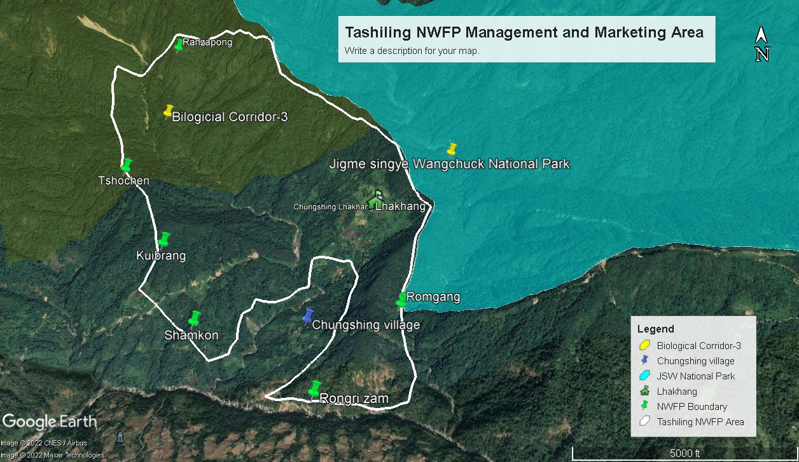

8. Marketing and sales plan

Table 04: Marketing and sales plan

Sl.No. | NWFP | Potentialmarket | Estimated quantity for sale per season(unit) | Form of Products  (dry/fresh) | Expected price per unit (Nu.) | Total(Nu)
1 | Sanja | Local  market | 50kg | Dry | 150 | 7500
2 | Tsoe | Local&  export | 200kg | Dry | 45 | 9000
3 | Amala | Local& export | 150kgs | Dry | 80 | 12000
4 | Pipla(round) | export | 50kgs | Dry | 80 | 4000
5 | Bamboo shoot | Local & Export | 40kgs | Pickle | 100 | 4000
6 | Guli | Local& export | 100kgs | Dry | 50 | 5000
7 | Chipley | Export | 150kgs | Dry | 35 | 5250
8 | Broom(Kuchu) | Export | 150pieces | Dry | 30 | 4500
9 | Kawlo | Local&  export | 120kgs | Dry | 40 | 4800
10 | Harchur | Local&  export | 20kgs | Dry | 150 | 3000
11 | Patsa | Local | 150pces | Fresh | 35 | 5250
12 | Labsi | LocalandExport | 150kgs | Dry | 30 | 4500
13 | Pangra | Export andLocal | 100kgs | Dry | 25 | 2500
14 | Putka | Export andLocal | 7 bottles | Raw | 5500 | 38500
 | Total Amount |  |  |  |  | 109800

9. Marketing arrangements

Table 05: Market arrangement procedures of the group
Activity | Procedures
Harvesting of products | NWFPs will be harvested as per the harvesting prescriptions for sustainable harvesting prescribe in table 02.
Postharvest practices | NWFPs will be dried in the sun and packed in the cartoon box after weighing its quantity.
Marketing of products | All the dried Non Wood Forest products will be collected and weigh individually as per species by management members. They will call open buyers and sellers in their area in consultation with Geog Forestry In-Charge.
Income sharing | The payment will be made to the member s as per the quantity of collection made by them after deducting royalty, 3% Executive Committee service charge and 10% contribution to Community Development Fund.
Raising of community development fund | 10% contribution to Community Development Fund will be made in the account number of Tashiling NWFP Management and Marketing Group.
Payment to committee members for their service | 3% for committee service charge payment.

10. Benefits to the members

The benefit or income from sale of Non-Wood Forest Product will be equally shared among the active members who have worked for collection, transportation, seasoning and marketing of the products.
3% will be deducted for Executive member as their service charge and 10% will be deducted for Community Fund Development.

Sl. No | Particulars |  | Products (names) refer to Table 4. |  |  |  |  |  |  |  |  |  |  |  |  | Total Amount (Nu)
 |  | 1  Sangja | 2  Tsoe | 3  Amla | 4  Chipley | 5  Bamboo shoot | 6  Kucho | 7  Guli | 8  Labsi | 9  Kawlo | 10  Pipla round | 11  Pangra | 12  Patsa | 13  Harchur | 14  Putka
1 | Revenues
a | Total quantity (unit) | 50 | 200 | 150 | 150 | 40 | 150 | 100 | 150 | 120 | 50 | 100 | 150 | 20 | 7 | 1437
b | Market price (Nu per unit) | 150 | 45 | 80 | 35 | 100 | 30 | 50 | 30 | 40 | 80 | 25 | 30 | 150 | 5500 | -
c | Total revenues from forest product sales (a*b) | 7500 | 9000 | 12,000 | 5250 | 4000 | 4500 | 5000 | 4500 | 4800 | 4000 | 2500 | 5250 | 3000 | 38500 | 109800
A | Total revenues | 7500 | 9000 | 12000 | 5250 | 4000 | 4500 | 5000 | 4500 | 4800 | 4000 | 2500 | 5250 | 3000 | 38500 | 109800
2 | Expenses
a | Packaging materials | 1000 | 1000 | 1000 | 1000 | 1000 | 1000 | 1000 | 1000 | 1000 | 500 | 500 | 500 | 500 | 1000 | 12000
b | Royalty | 900 | 3200 | 750 | 700 | 100 | 100 | 500 | 750 | 200 | 100 | 150 | 100 | 100 | 140 | 7790
c | Transportation costs | 200 | 1000 | 300 | 500 | 300 | 500 | 500 | 500 | 500 | 300 | 300 | 300 | 200 | 500 | 5900
d | Compensation fee to executive committee for marketing products (3%) | 225 | 270 | 360 | 158 | 120 | 135 | 150 | 135 | 144 | 120 | 75 | 158 | 90 | 1155 | 3295
e | Contribution to community development fund(10%) | 750 | 900 | 1200 | 525 | 400 | 450 | 500 | 450 | 480 | 400 | 250 | 525 | 300 | 38500 | 45630
f | Incidental expenses |  |  |  |  |  |  |  |  |  |  |  |  |  |  | 5000.00
B | Total expenses |  |  |  |  |  |  |  |  |  |  |  |  |  |  | 44965
C | Total benefit (net-income) of group members  (total revenues A – total expenses B) |  |  |  |  |  |  |  |  |  |  |  |  |  |  | 64835
D | Average income to group members (C/ no of group members) |  |  |  |  |  |  |  |  |  |  |  |  |  |  | 12200
E | Price per unit paid to group members (C/1a) |  |  |  |  |  |  |  |  |  |  |  |  |  |  | 76.40

11. Benefits to the group
From the sale proceeds and membership fees collected from the group members, the group will collect Nu.7550.00 annually. From the collected amount a certain percent of it will be used to meet common expenses like purchase of stationaries, meeting cost of food and refreshment during group annual meeting and guest entertainment. It was projected that the group will spend around Nu. 4000.00 for running the group activities. After deducting the overhead expenses, the group expect to save Nu. 7400.00 annually and will have total saving of Nu. 37000.00 by the end of plan period. Refer Table 5 for detail information.

Table 06: Financial projection of the group.

Sl. No | Particulars | Amount (Nu)
A | Revenues
1 | Membership fees | 900
2 | Contribution to the Community Development Fund (CDF) from sales of product Sanja | 750
3 | Tsoe | 900.00
4 | Amla | 1200
5 | Chipley | 525
6 | Bamboo shoot | 400
7 | Kuchu | 450
8 | Guli | 500
9 | Labsi | 450
10 | Pipla | 400
11 | Pangra | 250
12 | Patsa | 525
13 | Harchur | 300
14 | Putka | 5500
 | Total revenues | 7550
B | Expenses (only include expenses that will be paid from the group funds)
1 | Permit fees | 500.00
2 | Annual Group Meeting | 1500.00
3 | Office stationeries procurements | 500.00
4 | Other miscellaneous expenditures like visitors | 1500.00
 | Total Expenses | 4000
C | Balance: Total revenues – total expenses | 7400

Part B: Group’s BY-LAW
16

12. NWFP management & marketing group members | 12.1 Responsibilities and rights of members  - Members shall have authority to re-elect the executive committee members if they were not honest.  - Collect NWFP only after general meeting or after obtaining harvesting permits from the Range office, Gelephu.  - The group shall work for the interest of NWFP management and marketing group  - The group should explore market for the agreed NWFPs (14 species) and signed as per NWFP agreement protocol  - All group members should attend meeting(Annual/Quarterly/Emergency) voluntarily and with enthusiasm whenever requires  - Ensure and maintain quality products during the time of sale  - Labour hire beyond 2 labours is not allow from outside the groups as to ensure stringent management  - Collection of listed NWFPs within the family members of group members  - Pay membership fees annually  - Audit the executive members as per the situation  - Protect/stop outsiders from collecting 8 NWFPs species within the demarcated area  - Collect NWFPs which are listed in the signed agreement.  - The fund in the bank can with drawn by committee member only after the consensus of group member where the decision will take during Annual NWFPs Meeting  - Act as per the NWFP management and Marketing plan.
13. Executive committee | Name of Chairperson: Rinzin Wangmo  Contact No: +975-17953657

13.1 Responsibilities of Chairperson:
- Obtain NWFP collection permit from the forest range office, Gelephu.
- Coordinate and chair the meeting
- Coordinate the auctioning of the products in collaboration with the concern agencies (DFO, RO, DAMC-Gelephu, Traders and others )
- Solve conflicts arises within the group or with outsiders
- Explore market opportunities for 14 NWFP products specified in the management and marketing plan.
- Seek training and technical support from relevant organizations like forest range office, Gelephu, DAMC-Gelephu and RDTC, Zhemgang.
- Coordinate auction for sale of products
- Direct the groups and executives members as per management plan
- Disseminate harvesting period to members as mentioned in the Management and marketing plan
- Represent group during the meeting or training outside the chewog
- Co-signatory (Secretary and Treasurer) for cash withdrawal from the bank
- Liaised with concern agencies and traders in fixing date, price and venues for sale of NWFPs.
Name of Secretary:Tenzin Wangmo
Contact No: +975- 17764122

13.2 Responsibilities of Secretary:

- Chair the meetings in the absence of the chairperson.
- Provide assistance to the chairperson.
- Maintain records and keep minutes of meetings.
- Coordinate to conduct annual NWFP Meeting.
- Assist the Treasurer in maintaining the cashbook and bank book
- Check the quality of the products
- Maintain all the records (the group annual NWFP collection and sale record)
- Prepare annual progress reports of the group and submit to the forest range office, Gelephu.
- Draft official correspondences and submit to the chairperson for signatory
- Maintain stock registers of the group.
- Disseminate information to group related to price and quality requirement.
- Resolve the boundary disputes in collaboration with chairperson.
- Counter sign for withdrawal of groups fund from the bank.
- Maintain attendances registers of the group.
Name of Treasurer: Sangay Kunzang
Village: Chunshing
Contact No +975-77248652

Responsibilities of Treasurer:
- Maintain cash transaction records
- Keep record of activities carried out in the group
- Present accounts statement during Annual Group Meetings.
- Attend the auction with other members of Executives Committees
- Deduct 10% from each sale of NWFP species from respective members and deposit to the group account
- Deduct 3% from each member from sale of NWFP species and reserve it to pay incentives to the executive members(Coordinator, Secretary and Treasurer)
- Make payment of 1% each to Coordinator, Secretary and Treasurer as an annual incentives
- Shoulder secretary’s responsibilities in their absence due to emergencies.
- Collect membership fee annually and deposit in the group Account
- Collect the fine and penalties jointly with Chairman, Secretary, and deposit in the group account.
- Maintain all the sale records of listed NWFPs species during the auction.

14. Tenure of committee member | The executive members will serve for 5 years
15. Incentives to the committee members | No salary will be paid to an elected executive committee. However, they are eligible for a lump sum of Nu. 300/ day while on duty of the NWFPs Group outside the Gewog. But, they shall not be eligible to claim incentives from the group if they are paid by other agencies.
16. New Membership  Membership Registration fee and annual contribution | - The communities residing and registered in the same chewog are eligible to join the Tashiling NWFP Management and Marketing Group without paying any penalties. However, this will apply only to those new members joining the group within one month after plan approved and handed over to the group.  - Son(s)/daughter(s) of the members can join in the group after paying only membership fee of Nu. 100 and become member.  - Members outside their group must pay membership fees plus amount equivalent to one person’s shares accumulated till that year to become a members. However, he/she should have a Census and Thram in the same chewog  16.1. Resignation of members  - The member can resign after submitting an application to theChairperson stating his/her problems and difficulties. The matter should be further discussed in the Annual NWFP Meeting and endorsed by all the members  - If members happen to resigned without informing to executives members or members shall fine sum of Nu.500/member. Additionally, he/she shall not be eligible to claim for entitlement accumulated till that year.  - If the members have to transverse/migrate to other destination, then resignation shall be allowed, but without giving its benefits  - The actual share after calculating from gross amounts (Money in the group Account) will entitle only if the member is decease, retarded & no one to attend meeting on his/her behalf and it should endorse by all the group members  - If executive committee members does not delegate his duty as per their ToR, they shall be warned by the Group members in first instance. However, if repeated a fine of Nu. 500 will be levied in second time and finally termination without benefit if it is repeated for the third time.  - However, if the committee members/members did not function as per ToR then issues should be discussed in the annual/quarterly meeting and if he/she want to resign can do so without benefits and shall not entertain in group in the future;  - Any resignation and new comers name lists must reported to DFO Officeand Beat Office for updating of member list;  - Above personal will not entertain in the group in the future.
17. NWFP group fund management and utilization | - The group shall contribute 10% of the net price of NWFPs and membership fee of Nu. 100/- per member annually, since the balance amount of the group fund is minimal, it will be retained un-utilized for another 5 years.  - All the fines and penalties imposed and accumulated shall deposits in their account.  - Donation and contribution, shall directly deposited in the account

18. Conflict Management  Conflict resolution | - In case disputes or conflicts arises among communities with regard to access to certain areas for NWFP harvesting; the matter shall be put to the Gewog Tshogchung (GT) Dzongkhag Tshogdue (DT) for further decision.  - Conflicts or disputes within the NWFP Management Group, which cannot be resolved by the group members shall be forwarded to the coordinator for settlement. If the case cannot be resolved, it shall be forwarded to the Gewog Administration.  - In case there is a conflict between the NWFP Group and outsiders, the case shall be forwarded to the Gewog Administration by the Chairperson.
19. Groups meeting and purpose | - Group shall convene one annual meeting in the month of March every year to consolidate the activity progress of the years. During that all the members shall congregated to discuss and hear their progresses. However, short meeting shall occur prior to harvest of every NWFP Products. The meeting will be basically conducted for the deliberation of following points:  - Review of past minutes of meeting  - Showcase and present financial status information  - Progress of each years and constraints encounter  - Work planning for forth coming season or year  - Compilation of Annual Work Plan and progress reports  - The meeting resolution will be adopted only if 2/3 of members agree to it.
20. Fines and penalties | - The NWFP products from the private land shall sold to their group to avoid misuse of resources. If found selling directly to the trader, the group has an authority to seize and confiscate the products. It shall be sold by group and amount generated shall deposit in group account  - A fine of Nu.500 will be imposed to defaulter collecting NWFP resources before collection time. If do so, products will be confiscated and revenue generated shall credited in group account  - Collecting products inside delineated boundary by the Non-member shall fine Nu.1000/ and also confiscation of products. Those confiscated product shall be sold by the group and the fund generated from the sale will be deposited to the group account  - If the products bypass executive members and sale directly to the traders than defaulter shall fine the triple market values of that products. Products shall be seized and sold by the groups. Payment shall be credited in group account;  - Members not following the harvesting guideline during collection as prescribed in the management plan shall be fined Nu.300/ per occasion.  - Group member not attending meeting/training/workshop, any activities related to NWFP management shall fine Nu.165/- per day and if repeated for three times, he/she shall be expelled from the group without benefits,  - If the culprit refuses to pay the fines and penalties to the Committee member, the matter shall forward to Chewog Chupen, Tshogpas and further to Gup, Gewog Administration for settlement  - In case, committee members misuse of group resources, they shall be asked to refund and as well terminate from the post without any benefits. A new member will be elected during the annual/quarterly meeting.
21. Tenure of the management plan | - The NWFP Management & Marketing plan developed shall be valid for a period of 5 years.
22. Power of the Department | The Department has the right to cancel the NWFP management and marketing plan in case of any violation of the management plan or in the event of inability to implement the activities as per the approved management plan. This will be exercised as per the provisions made in the forest rules and regulations.

23. Monitoring and evaluation scheme

Expected result | Monitoring activities | Indicators | Means of verification | Responsible agencies | Frequency/ remarks
Application of harvesting guidelines results in sustainable resource base | Regular inspection of NWFP harvesting sites | Description on resource availability | Field trip reports | DoFPS | Regular field visits during the harvesting season
 | Recording of actual harvested quantities | Records on actual harvested quantities | No. of Harvesting & transit permits issued and record books of NWFP groups | DoFPS/ NWFP Groups | According to NWFP harvesting seasons
Income of NWFP groups enhanced | Recording of actual income from NWFP sales | Records of NWFP sales | Bank account/ record books of NWFP groups | NWFP groups | Seasonally
 | Recording of NWFP produce marketed and exported | Records of marketed and exported NWFP produce | Marketing reports  Transit permits Export permits and clearance | DoFPS | Regularly
Movement and export of NWFPs properly recorded | Regular patrols and checks of movement of NWFPs | All movement of NWFPs properly recorded | No of Harvesting/ transit/ export permits and phytosanitary certificate issued | DoFPS/  BAFRA | Regular
Implementation of NWFP framework properly monitored | Organization of coordination meetings with stakeholders | Data available about the implementation of the NWFP interim framework | Meeting minutes  Records on marketing and resources available | DoFPS/  NWFPs Group | Bi- annually
 | Annual compliance monitoring and preparation of report | Annual report showing data on marketed NWFPs, income generated and resource availability per NWFP group and district | Annual monitoring report | DoFPS/  NWFPs Group | Annually

Annexure I: Name lists of the Tashiling Shingmen Duelen and Tshongdrel Tshogpa, Chungshing.

Sl No | Name of household respentative | CID no | House No | Thram No | Village
1 | TenzinWangmo | 11308001015 | Pa-8324 | 302 | Chungshing
2 | Kartungmo | 11308001002 | Pa-8-325 | 675 | Chungshing
3 | Napen | 11308000156 | Pa-8-330 | 294 | Chungshing
4 | Nazom | 11308001038 | Pa-8-327 | 227 | Chungshing
5 | NimDem | 12004001204 | Pa-8-335 | 1089 | Chungshing
6 | RinzinWangmo | 12001002982 | Pa-8-328 | 293 | Chungshing
7 | Penmo | 11308001130 | Pa-8-347 | 304 | Chungshing
8 | Jaimo | 11308001092 | Pa-8-346 | 302 | Chungshing
9. | Sangay Kunzang | 11308001033 | Pa-8-326 | 1093 | Chungshing

